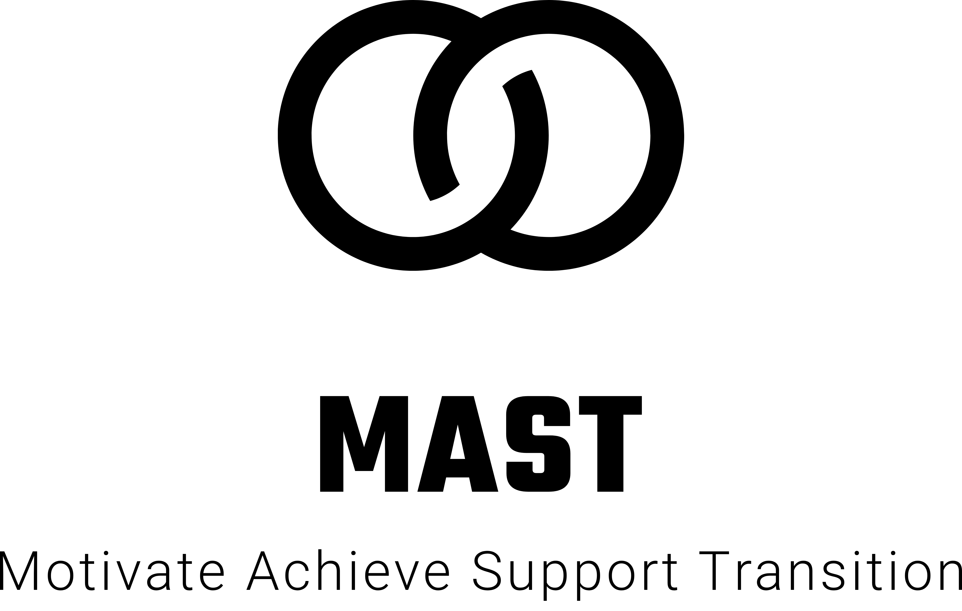
SAFEGUARDING POLICY
1. POLICY STATEMENT
MAST Services undertakes to ensure that all children, young people and adults at risk who attend our premises or come into contact with the organisation will be respected, valued and protected. We accept the moral and statutory responsibilities to provide a duty of care for children, young people and adults at risk and implementing procedures to safeguard their wellbeing and protect them from abuse.

Making sure our employees and volunteers are carefully selected following the guidelines from our staff vetting and safer recruitment policy, trained, supervised and have an appropriate DBS clearance in place we will ensure that all employees and volunteers adopt and abide by MAST Services code of conduct, protection policies and procedures and respond to any allegations appropriately in accordance with the reporting procedure detailed in this policy. Where our employees are working at other premises there may be a requirement to follow that institution’s safeguarding procedure, whilst ensuring that MAST services has a record of the actions taken.

Where learners and clients go out into the workplace, a Workplace Suitability Risk Assessment will be carried out before commencement of the work placement and this will determine if DBS checks are needed for any employees in the workplace.

We will provide parents, carers, children, young people and adults at risk with information
about what we do and what they can expect from us by informing them how to voice any concerns they may have.

MAST Services will continue to adopt and evolve best practice to safeguard and protect children, young people and adults at risk from abuse and neglect by working with appropriate agencies and partners to implement broader preventative and precautionary measures.

2. SCOPE AND PURPOSE
MAST Services has a legal and moral responsibility to protect children, young people and adults at risk and will fully comply with their legal obligations relating to child protection and safeguarding, as detailed in the following pieces of legislation:

- The Children Act 1989
- The Children Act 2004
- Working together to Safeguard Children 2018
- What to do if you are worried a child is being abused 2015
- Keeping Children Safe in Education 2018
- Protection of Freedoms Act 2012
- Care Act 2014
- Keeping Learners Safe 2015
- Safeguarding Children: Working Together Under the Children Act 2004
- All Wales Child Protection Procedures 2008
- Our Children& Young People: Our Pledge: a ten year strategy for children and young people in Northern Ireland 2006-2016
- Revised Prevent Duty Guidance for England and Wales (2015) Revised March 2016
- Modern Slavery Act 2015
- Data Protection Act (2018) & The General Data Protection Regulation (GDPR) (2018)

This policy applies to all MAST SErvices employees and volunteers and sets out the procedure and processes to be followed when dealing with child protection and safeguarding issues across the business.

3. GENERAL PRINCIPLES
MAST Services Safeguarding Policy and associated policies are based on the following principles:
- The welfare of children, young people and adults at risk is the primary concern;
- All children, young people and adults at risk have the right to protection from abuse;
- It is the responsibility of experts to determine whether or not abuse has taken place but it is everyone’s responsibility to report any concerns using the appropriate procedures outlined in this policy;
- All incidents of suspicious practice and allegations must be taken seriously and responded to swiftly and appropriately;
- Confidentiality must be upheld in line with the Data Protection Act 2018 and the General Data Protection Regulation (GDPR) (2018)
- Protecting children from radicalisation is seen as part of the company’s wider safeguarding duty and is similar in nature to protecting children from other forms of harm and abuse.

4. DEFINITION OF TERMS
4.1 CHILD
- A child is legally defined as anyone under the age of 18 unless he or she has defined special needs.
4.2 Adult at Risk
The definition of an adult at risk is a person aged 18 or over; and
- Has need for care and support (whether or not those needs are being met); and
- Is experiencing, or is at risk of, abuse or neglect; and
- As a result of those needs is unable to protect him or herself against the abuse or neglect or the risk of it.

4.3 ABUSE
Abuse is the violation of an individual’s human rights. It can be a single act or repeated acts. It can be physical, sexual, or emotional. It also includes acts of neglect or an omission to act. In all forms of abuse there are elements of emotional abuse. Adults at risk may also suffer additional types of abuse such as being manipulated financially or being discriminated against.
Other examples of abuse include inflicting physical harm such as hitting or misuse of medication, rape and sexual assault or exposure to sexual acts without informed consent, emotional abuse such as threats, humiliation and harassment, exploitation, ignoring medical or physical needs, withholding of necessities of life such as food or heating. This list is not definitive.

5. PROCEDURE
MAST Services believes that in order for safeguarding to impact on all aspects of the operational life of our employees and volunteers it must become the informed responsibility of all. All employees, volunteers, and partners including placement providers; employers and delivery partners have a responsibility and duty of care to actively make the learning environment safe and secure for all and take appropriate action where necessary in order to achieve this effectively.

In order to ensure appropriate action is taken in such circumstances MAST Services has adopted and utilised the principles of the 5 R’s Model that should be implemented and followed across all operational activities. Further information on this model and supporting flowcharts can be found below.

- Recognition
- Response
- Reporting
- Recording
- Referral

5.1 RECOGNITION
This is the responsibility of all employees and volunteers involved in learner and client facing roles.

Recognition involves the ability to recognise behaviour that may indicate abuse as this is of fundamental importance. Whether the abuse may occur on the organisation’s premises, in the home or in any other setting in which the learner or client may find themselves, all those playing a role in meeting the learners’ or clients needs should be aware and informed so that possible abuse can be recognised, investigated and acted on seamlessly and effectively.

Signs and indicators of abuse in young people and/or adults at risk may include direct disclosure. This isn’t always easy to recognise as such, as it may be that the learner or client is struggling to find the words, is using language the abuser uses for particular actions and body parts, or the disclosure is wrapped in analogy or euphemism which is difficult to identify. A learner or client may choose anyone in the organisation to disclose to (including tutors, assessors, advisors, administrative employees etc.), or indeed any of these may be the ones to spot concerning signs or behaviour in the learner or client. This is why all employees and volunteers are trained in how to recognise and respond to this situation, and how to report a concern.

Recognising signs and indicators of abuse is also difficult, as any signs could have another
explanation. It is vital that all employees complete their Safeguarding and prevent training, are able to spot signs, are not encouraged to overreact and assume abuse is occurring, and know when to pass on concerns to the appropriate person.

5.2 RESPONSE
This is the primary responsibility of the employee or volunteer that has been approached by the learner or client.

Appropriate response is vital. No report about possible abuse or neglect should ever be ignored. In order to determine the most appropriate response, find out if you are dealing with an allegation from a learner or client against an employee/volunteer, another learner or client or another person outside the organisation. Is the disclosure from an individual alleging abuse to themselves or another? Is this the reporting of a concern or suspicion? What is alleged to have happened? Your role in the moment when you respond is to ascertain what you are dealing with and to listen. The learner or client may be very scared and emotional in telling you this information, so you must stay calm, use effective empathic listening skills, and not let them know if you are feeling panicked, shocked or outraged at what you are hearing, as this may shut them down. You need to ask open questions (not leading or suggestive ones) and gather just enough information to know that it is a disclosure of abuse that needs to be passed on, and how immediate the danger or harm is to the individual.

Do not lead or probe with questions – ask only completely open questions. Demonstrate interest and concern, and take it seriously, even if you are finding it difficult to believe because it is so shocking, or perhaps it is an allegation being made against someone known to you. Finally reassure that they have done the right thing by telling you, as you will do what you can to help. Reassure the learner or client that they have done the right thing in reporting their concerns and that you will do everything you possibly can to help. Do not make unrealistic promises by agreeing to ‘keep it quiet’ but ensure that they are aware of who you have to tell and what might happen next, and that this is for their safety.

It is not your role to investigate the situation; you just need to be clear that it will be treated in confidence but recorded and passed on to the appropriate people/person. Ensure that testimony is recorded and reported, and that the complainant and subject of the complaint are treated in line with policy and guidance.

5.3 RECORDING
The recording of the testimony should be undertaken via the standard Safeguarding Report Form and must be completed by the employee that has taken the testimony and been approached by the learner or client.

You should record precisely what has been alleged, using key phrases and words the individual used. You are not expected to remember every detail of the conversation, and therefore it is not recommended that notes or any other recording is made during the conversation, but immediately afterwards. You should also record your observations of the individual, as well as your interpretation of the facts as long as you clearly identify when you are doing so. This record should be passed on, and reported as below to the appropriate person, who should store it securely and separately to learners’ individual files. It should only be accessible to those who have responsibility over safeguarding matters.

5.4 REPORTING
Once the employee has recorded the testimony as detailed above on the Safeguarding Report Form this must be reported and forwarded as soon as possible to the designated person ‘Fiona Styles’ without delay.

Once you have reported concerns about abuse to the designated person, the responsibility for taking action may revert back to the original employee reporting the concern in cases where further information is required, where the matter is reviewed and confirmed not to be a safeguarding issue, or is more of a signposting or support need. The reporting employee will continue to deal with this in these cases.

However, where the case is confirmed as a safeguarding issue requiring a formal referral to an appropriate agency e.g. The Police, Child Services, Adult Services, the responsibility for making this referral will sit with the designated person.

Where a formal referral is required by the designated person you are within your rights to check
that appropriate action has been taken, but it may not be necessary for the designated person to share the details of this with you due to the confidentiality of the individual concerned.

5.5 LEARNER AND CLIENT REFERALS
As detailed above, formal learner and client referrals must only be made by the designated person. They should be provided with enough information on the Safeguarding Report Form to make that referral, however this may require further gathering of information with the appropriate people either inside or outside the organisation.

Based on this information the designated person will make a decision on what action to take: i.e. whether to monitor and record the concern, or to refer it. Only the Designated Person is permitted to make learner or client referrals outside MAST Services to the appropriate agencies. This is to prevent numerous referrals being made for the same incident; it also allows consistency in the process, and means that the designated person can build relationships with their local referral agencies.

Where it is identified that a learner or client poses a risk, or caused some form of harm to a child, young person or vulnerable adult whether through an act or omission, the Company is legally required to make an appropriate referral to the Independent Safeguarding Authority and/or Disclosure Scotland.

Learner/client ISA/DS referrals must only be made by the designated person following consultation with the appropriate Line Manager. Prior to a formal referral advice and clarification must be sought from the Independent Safeguarding Authority/DS to assess whether the situation requires such a referral and once referred it will be their decision whether or not to take any further action.

5.6 EMPLOYEE REFERALS
Where it is identified that an employee or volunteer poses a risk, has abused their position of trust or caused some form of harm to a child, young person or vulnerable adult whether through an act or omission, MAST Services is legally required to make an appropriate referral to the Independent Safeguarding Authority and/or Disclosure Barred Services.

Employee ISA/DBS referrals must only be made by the Designated person following consultation with the appropriate Line Manager. Prior to a formal referral, advice and clarification must be sought from the Independent Safeguarding Authority/DBS to assess whether the situation requires such a referral and once referred it will be their decision whether or not to take any further action.

5.7 Disclosures Flowchart
The below flowchart should be followed by all MAST Services employees and volunteers in
circumstances where they are approached by a learner or client about a potential Safeguarding
issue.

Formal referral required designated person to make referral to
appropriate
agency and
update
Safeguarding
Report Form
No formal referral
required, matter to
be referred back
to staff member
and appropriate
support and
signposting to be
communicated
Where appropriate Investigating Manager to be allocated and Investigation conducted in line with Trans4m’s Disciplinary Policy. Pending outcome of Investigation appropriate action to be taken and ISA/DS referral to be made where appropriate

Designated person to review Safeguarding Form and determine whether a formal referral or whether additional support or signposting is required
Director to liaise with line manager and Designated Person to discuss
appropriate action to take
If the concern does not relate to a staff member or
volunteer contact your local designated person without delay
If the concern relates to a staff member or volunteer contact managing directors
without delay
As soon as possible after the disclosing conversation, make a note of what was said, using the learner/client’s own words on the Safeguarding Report Form. Note the date, time, and any names that were involved or mentioned. Do not use this as an opportunity to interrogate the learner/client. Make sure you sign and date your record
Reassure the learner/client that ‘they did the right thing’ in telling someone. Tell the learner/client what you are going to do next i.e. seek advice and revert to them
Do not promise to ‘keep it a secret’. Use the first opportunity you have to say that you will need to share the information with others. Make it clear that you will only tell the people who need to know and should be able to help.

Employee/volunteer listens carefully to what is said, allow the learner/client to talk at their own pace, and ask questions only for clarification. Do not ask questions that suggest a particular
answer
Learner /client approaches employee with a concern.
Employee/volunteer does not delay in acting, allows the learner/client to discuss their concerns in a confidential environment

6. STORAGE OF DOCUMENTATION
All safeguarding documentation including, safeguarding report forms; supporting emails; referral information and statements must be passed to the designated person for secure storage, monitoring and logging. All such records are stored confidentially in a safeguarding file within a locked cabinet or drawer, the safeguarding records are to be kept separate from individual student records.

Where documentation is required to be temporarily held locally all documents must be stored in a locked cabinet and accessible only to the designated person. Once documentation has been forwarded centrally and receipt of the documentation has been confirmed by a Designated Person all local records must be destroyed securely.

7. SUPPORT
MAST Services is committed to providing access to all learners, clients, parents, carers, employees, and volunteers to ensure we are providing timely and effective support to maintain a safe and secure environment for all.

8. ALLEGATIONS AGAINST EMPLOYEES

All employees should take care not to place themselves in a vulnerable position with a child/young person or adult at risk and be aware of appropriate professional conduct. It is always advisable for interviews or work with individual young persons, adults at risk, or parents to be conducted in a visible arena in view of other adults.

We may occasionally receive complaints or allegations against an employee; but it is important that a fair and balanced approach should be taken to ensure that both the complainant and the employee are safeguarded.

- If such an allegation is made, the employee receiving the information must take the issue seriously and should immediately inform Fiona Styles – designated person
- No action should be taken in respect of gathering information / statements from other employees / learners until directed by the designated person.

Where it is subsequently found that an allegation was made with malice aforethought, Fiona Styles will determine an appropriate course of action. This may include disciplinary action against the accuser, acceptance of a written apology (subject to agreement about future behaviour) or other such sanctions as are deemed appropriate.

THIS POLICY WILL BE REVIEWED – AFTER 12 MONTHS

Signed _________________________ Director Date 22nd June 2019

